MULTI -LINE INSURANCE POLICY AND
CLAIMS MANAGEMENT SYSTEM
COLLEGE NAME: UNIVERSITY COLLEGE OF ENGINEERING THIRUKKUVALAI
COLLEGE CODE: 8222
TEAM MEMBERS:
HARIHARAN R (TEAM LEAD)
MUTHAMIL SELVAN T
BHUVANESH C T
EMAIL ID:
HARIHARAN R : hhariharan708@gmail.com
MUTHAMIL SELVAN T : t.muthamil555@gmail.com
BHUVANESH C T : bhuaneshthi@gmail.com
NM ID:
HARIHARAN R : 89EB08A5DEDC3B48B3349612B3B64218
MUTHAMIL SELVAN T : 6C4BDAACAD9BB1FB31A47784B2502B96
BHUVANESH C T : DB1E37315FFD9B494E546AB8931A54DA
PROJECT DEMO VIDEO LINK:
https://drive.google.com/drive/folders/1ZoeAqpOgcVQLCo7K5i-HjJjqiPcU_hmo?usp=sharing
GIT HUB LINK:
https://github.com/Muthamil-2306/Multi-line-insurance-policy-claims-management

1. PROBLEM STATEMENT
The insurance company manages Vehicle, Property and Life insurance through processes that can become slow and difficult to control when policy information, quotations and claims are handled separately. The proposed Salesforce solution brings these activities into one platform so policy and claim information can be maintained together.
- Standardize policy quoting and issuance.
- Capture product-specific information in a common data model.
- Automate claim creation, routing and approval.
- Provide role-based access to agents, adjusters and managers.

2. OBJECTIVES
- Create a flexible Policy and Claim data model for Vehicle, Property and Life insurance.
- Use Record Types and Field Sets for product-specific information.
- Build a guided Auto Quoting Screen Flow.
- Calculate premiums through Apex.
- Route claims according to policy type.
- Provide an LWC Claims Dashboard.
- Implement approval processing for high-value claims.
- Apply Sharing Rules and Permission Sets.
- Test automation and Apex before completion.

3. CHALLENGES
- Managing different fields for three insurance products.
- Routing claims according to the related policy type.
- Connecting Salesforce Flows with Apex logic.
- Building a useful adjuster dashboard.
- Maintaining security while supporting daily work.

Milestone 1: Core Data Model & Policy Configuration
User Story1: Creation of custom objects
1. Create Policy custom object:
- Go to setup, Click on object Manager.
- Click on create and select custom object.
- Fill the following details:
- Label: Policy
- Plural Label: Policies
- Object Name: Auto Populated
- Record Name: Policy Number
- Data type: Auto Number
- Format: P - {0000}
- Starting Number: 1 • Under optional features:
- Allow Reports, Activities and Track field History • Under Deployment Status:
- Select the deployed radio button.
- Under Search Status:
- Check the Allow Search checkbox.
- Click on save.

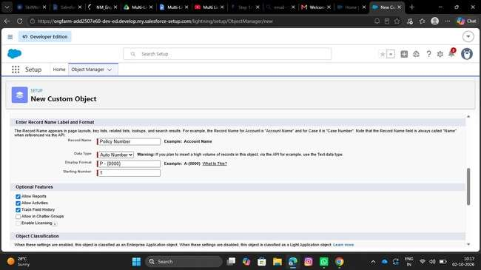
2. Define Record Types on Policy Object:
- Go to setup, Click on Object Manager.
- Search for Policy objects and click on Policy__c.
- In the left side panel, click on the record types.
- Click on New.
- Fill out the following details:
- Select the existing record type as Master.
- Give record type label as “Auto”
- Record Type Name will be auto populated.
- Give a meaningful description.
- Check the active checkbox.
- Check the Make Available checkbox for all the profiles.
- Click on Next.
- It will redirect to the Assign page layouts page, Leave everything as is, and click on save.

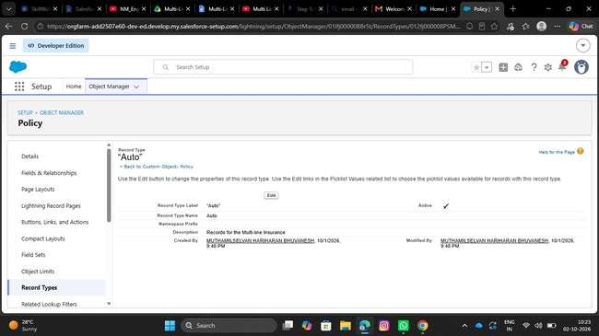

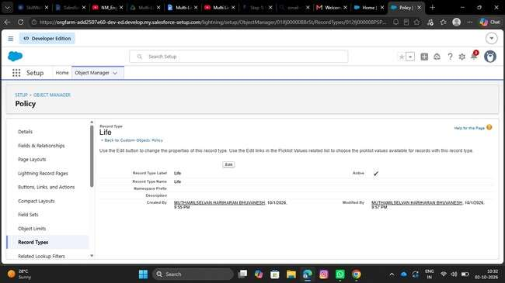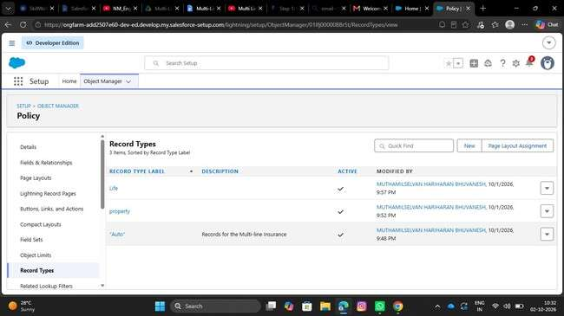
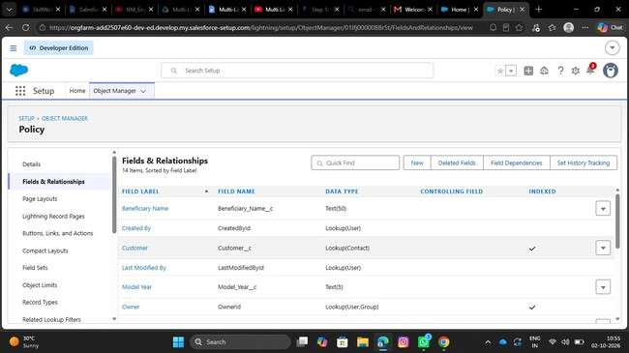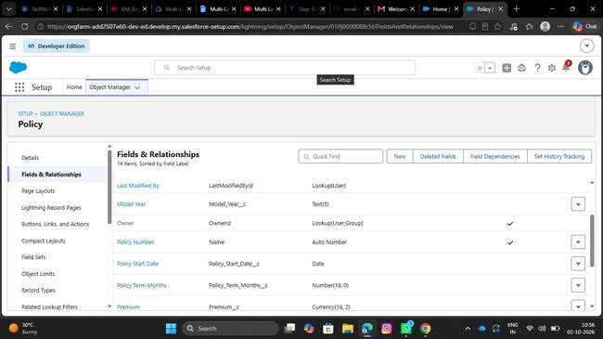
• 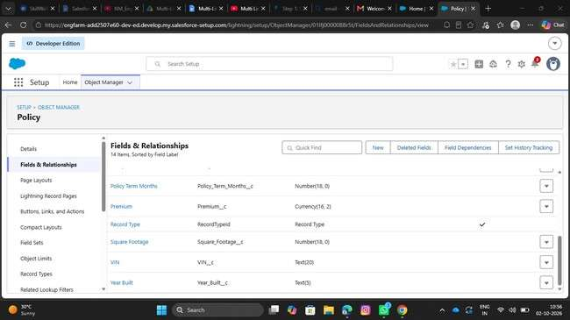
Repeat the same steps for creating the property and life record types as well.

Create Field Sets for policy specific data: o Go to setup, Click on Object Manager. o Search for Policy object and click on Policy__c. o In the left side panel, click on the Field Sets.
  - Click on New. o Fill out the following details: o Field Set Label as Vehicle o Field Set Name will be Auto populated. o Where is this used: In the policy object. o Click on save. o Click on the field set you have just created and it will redirect to the page layout setup. o Drag VIN, and model year fields to the field set and click on save.

• 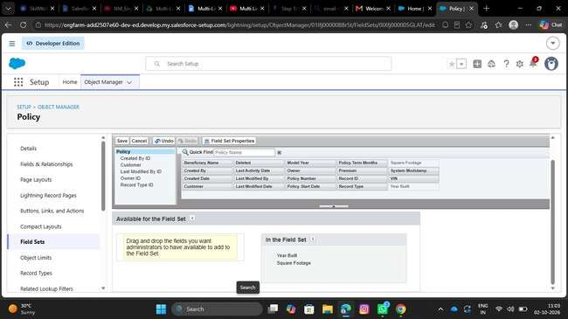
Repeat the same steps for creating the property and life Field sets as well.

3.1 Property FieldSet Requires:
  - Square footage
  - Year Built

3.2 Life FieldSet Requires:
  - Beneficiary Name
  - Policy Term Months

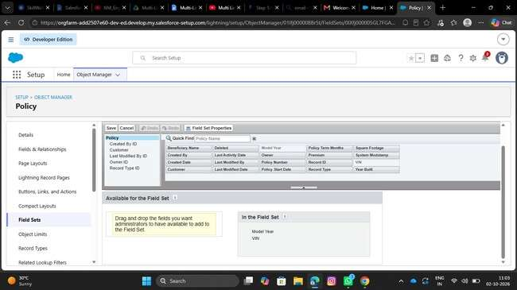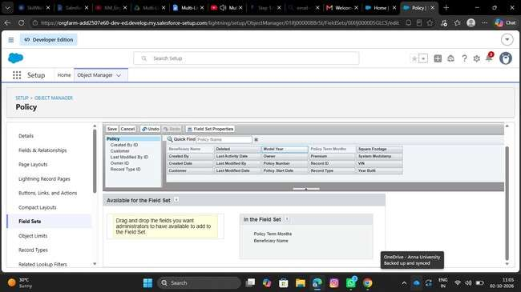
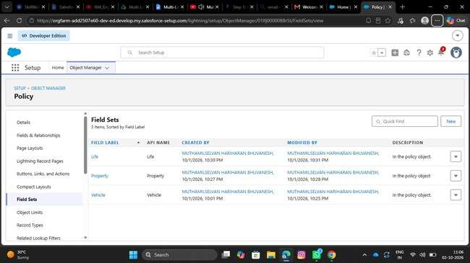
- Create Fields in the Policy Object:
S.No | Name of the Field | Data Type | Required
1 | Beneficiary Name | Text(50)
2 | Customer | Lookup(Contact)
3 | Model year | Text(5)
4 | Policy start date | Date
5 | Policy term month | Number(18, 0)
6 | Premium | Currency(16, 2)
7 | Square footage | Number(18, 0)
8 | VIN | Text(20)
9 | Year built | Text(5)

- Create Claim custom object:
  - Go to setup, Click on object Manager. Currency(16, 2) Number(18, 0) Text(20) Text(5)
  - Click on create and select custom object.
  - Fill the following details:
  - Label: Claim
  - Plural Label: Claim
  - Object Name: Auto Populated
  - Record Name: Claim Number
  - Data type: Auto Number
  - Format: C - {0000}
  - Starting Number: 1 • Under optional features:
  - Allow Reports, Activities and Track field History • Under Deployment Status:
  - Select the deployed radio button.
  - Under Search Status:
  - Check the Allow Search checkbox.
  - Click on save.

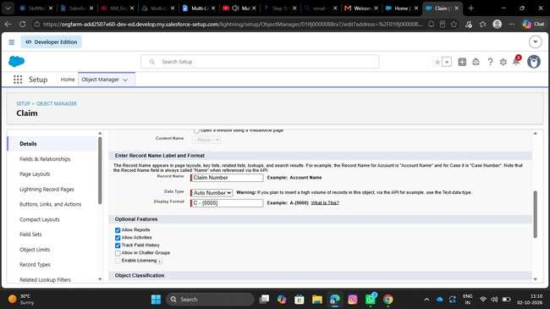
6. 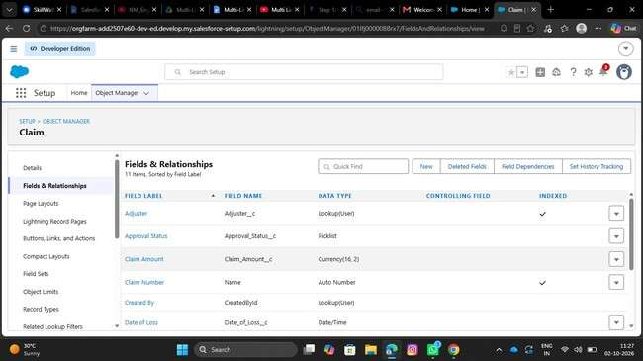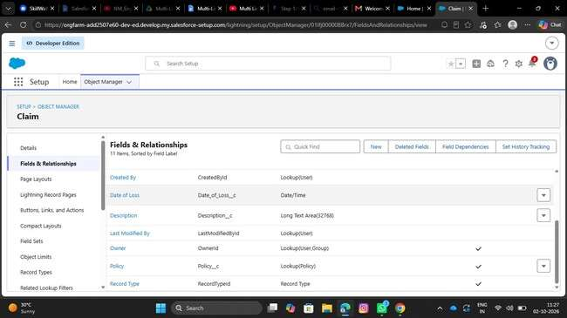
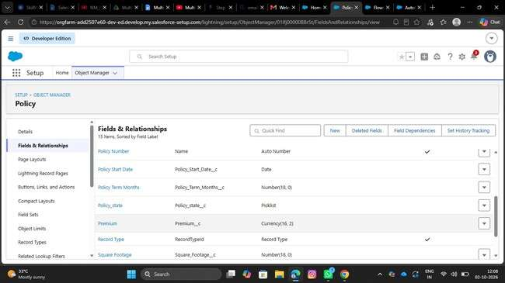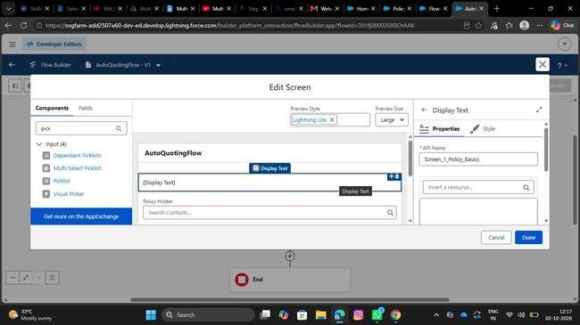
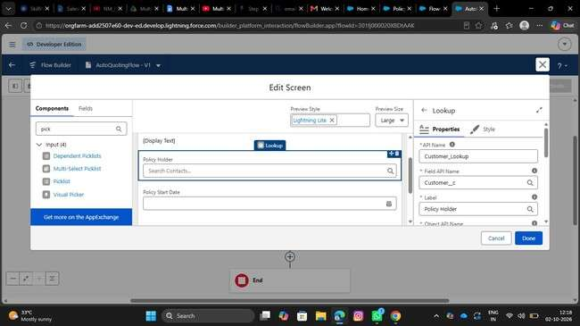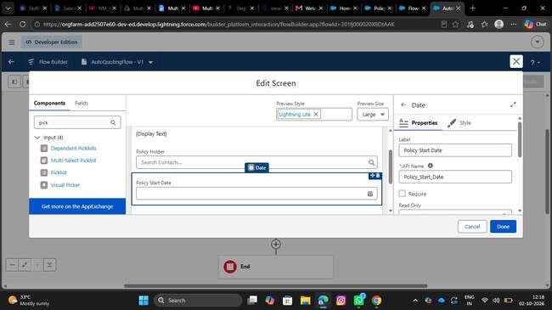
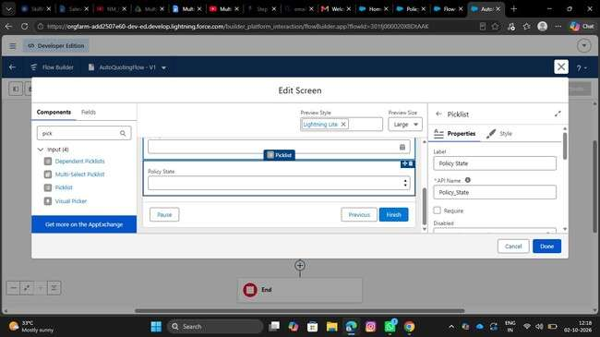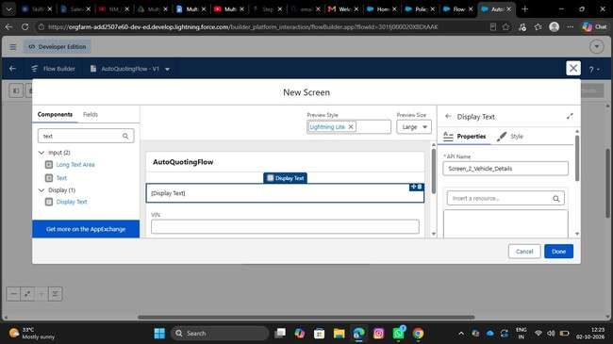
6 .Define Record Types on Claim Object:
- Go to setup, Click on Object Manager.
- Search for Claim object and click on Claim__c.
- In the left side panel, click on the record types.
- Click on New.
- Fill out the following details:
- Select the existing record type as Master.
- Give record type label as “Accident”
- Record Type Name will be auto populated.
- Give a meaningful description.
- Check the active checkbox.
- Check the Make Available checkbox for all the profiles.
- Click on Next.
- It will redirect to the Assign page layouts page, Leave everything as is, and click on save. //Repeat the same steps for creating the property and life record types as well. 7. Create Fields in the Claim Object: S.No 1 2 Field Name Adjuster Approval Status Data Type Lookup(User) Required Picklist(New, Submitted for Approval, Approved, Rejected) 3 4 Claim Amount Date of Loss Currency(16, 2) Date/Time

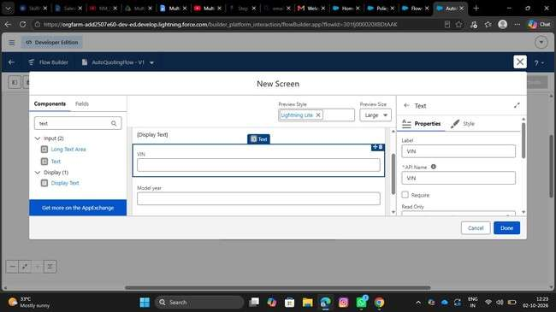
- . Create an AutoQuoting Screen Flow
  - Go to setup, Search for flows in the quick find box.
  - Click on flows and click on new flow.
  - Select Screen Flow and Click on Create.
  - Add Get Records Element immediately after the start element.
  - Give Label as Get Vehicle RT ID
  - Api Name will be auto populated
  - Select Record Type for Object
  - For Conditional Requirements, Select All Conditions are met
  - The Conditions include:
  - sObject Type Name Equals Policy__c
  - And
  - Record Type Name Equals Auto
  - Add Screen Element immediately after the Get Records Element
  - Give the label as New Auto Policy Quote - Basic Information
  - API Name will be auto populated.
  - Drag the display text component into the flow canvas
  - Give the API Name as Screen_1_Policy_Basics
  - Drag the Lookup Component into the Canvas, Give API Name as Customer Lookup, Field API Name as Customer__c, Label as Policy Holder, ObjectApiName as Policy__c
  - Drag Date component into the canvas, Give Label as Policy Start Date, API Name will be auto populated.
  - Drag the picklist component into the canvas, Give the label as Policy State, API Name will be auto populated, For Choice, Create a new Resource, Resource Type should be Picklist Choice Set, Give the API Name, Select the Policy for Object,
Select Picklist as Datatype, Select Policy State as Field and Click on save
  - Click on Done

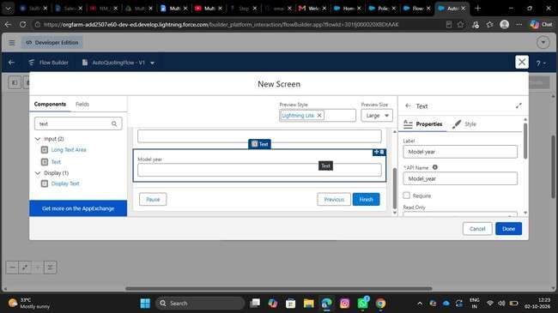
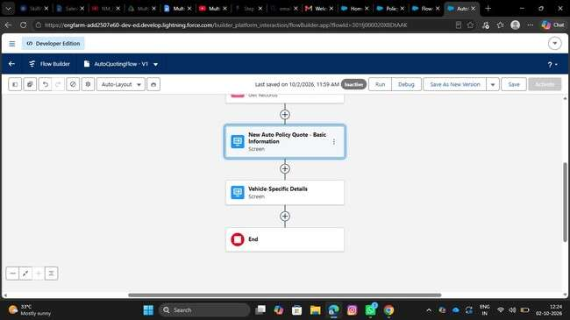
•

  - Give the label as Create Draft Policy, API name will be auto populated
  - Store field values manually
  - Select the policy object
  - Set fields for the policy object as shown below:
  - Customer —> From Basic information screen-> Policy Holder -> Record ID
  - Model Year—--> Vehicle information screen -> Model Year
  - Policy Start Date —> From Basic information screen→Policy Start Date
  - Policy State —> From Basic information screen —> Policy State
  - RecordType ID —> From Get Vehicle RT Id —> RecordType ID
  - VIN —> From Vehicle Information Screen —> VIN
  - Check manually assign variables checkbox
  - In the place of variable, create a new resource, Whose resource type is variable, API Name would be varPolicyId, Datatype would be Text, Click on Done.
  - Save the flow with AutoQuotingFlow
  - Activate the flow

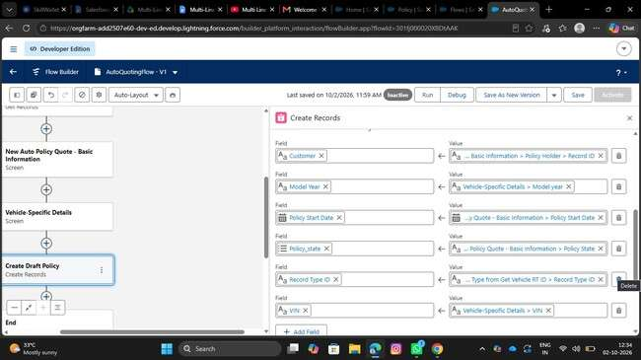

9. 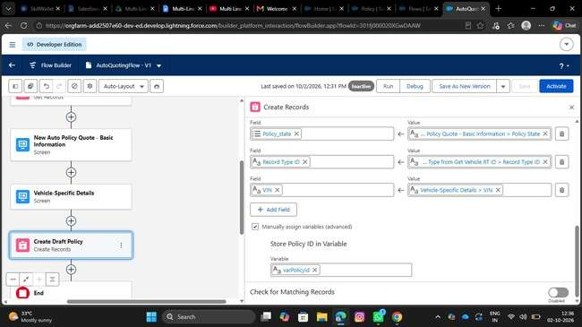
- .Create Validation Rule on Policy Object:
- Go to object manager, Search for the policy object and click on policy object
- In the left side panel, scroll down and find validation rules and click on it
- Click on New
- Give the rule name as VIN_Must_Be_17_Characters
- Check the active checkbox
- Write the following formula in the formula editor ○ AND( RecordType.DeveloperName = "Auto", LEN( VIN__c )<> 17)
- For error message, The Vehicle Identification Number (VIN) must be exactly 17 characters long for Auto Policies.
- Select error location as field and select VIN field • Click on Save
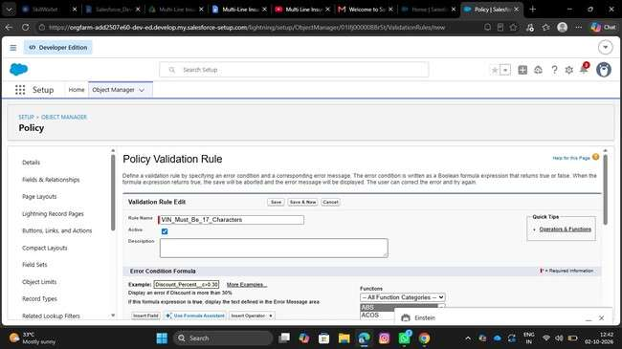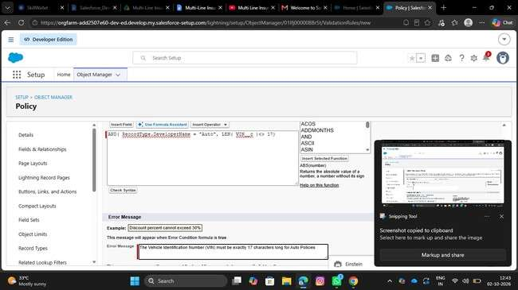
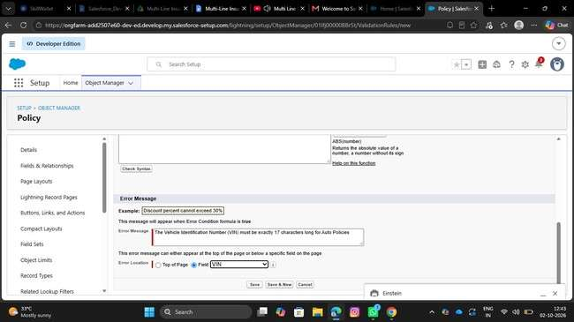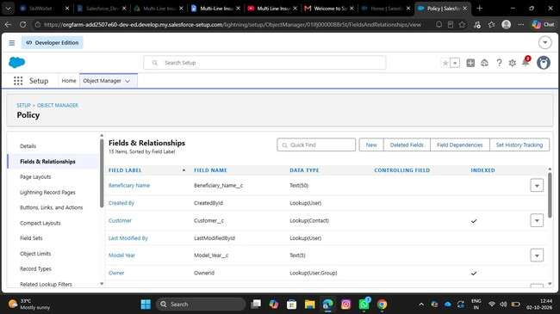
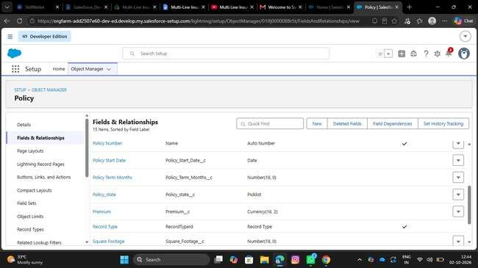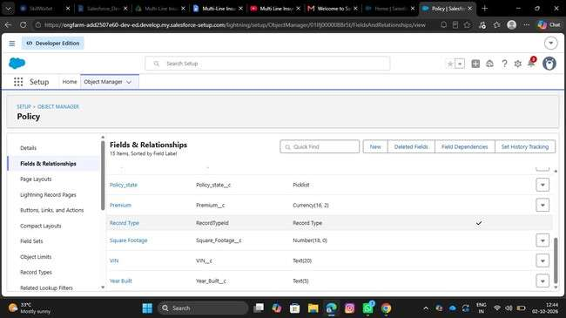
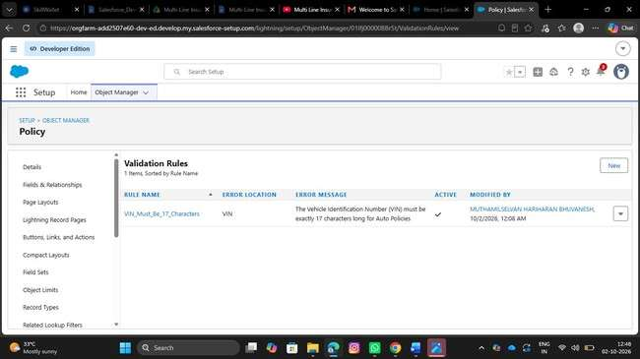
Milestone 2: Complex Policy Issuance & Claim Routing
Automation
1. Create an Apex Class (PremiumCalculator) with a method that accepts policy data
- Click on setup icon, Right click on developer console, Open the link in new tab
- At the top left corner, click on the file, then click on new, and click on Apex class, Give the name as PremiumCalculator and click on create.
- Paste the following code in the apex class:

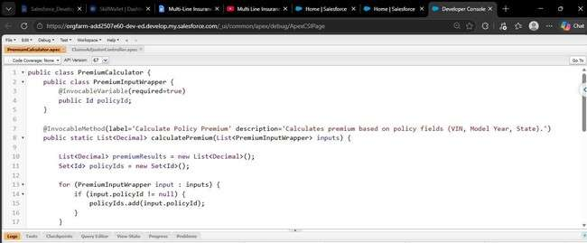

- Click on CTRL + S to save the apex class
- And this apex class need to be invoked in the
AutoQuotingFlow

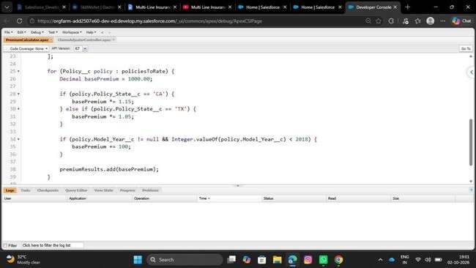

2. Integrate this Apex action into the final step of the AutoQuotingFlow to update the draft Policy record

- Go to setup, in the quick find box search for flows and click on flows
- Find for AutoQuotingFlow and open in the flow builder
- Under the Create Records element,
- Add an action element after the create records element.
- Give the label as Calculate Premium Action
- API Name will be auto populated
- Under set Input values, For policy Id, Set the varPolicyId variable created in the previous step
- Under view output resources, check the manually assign variables checkbox and for the output placeholder, create a resource
- Resource type would be variable, API Name would be varCalculatedPremium, Data type would be currency, Decimal places are ‘2’ and click Done.

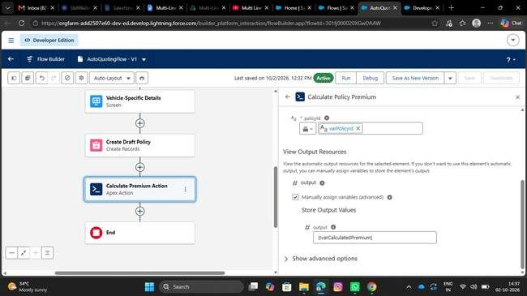
- After the action element, add the update records element, Give the label as Update Policy With Premium
- For how to find records to update and set their values, Select Specify conditions to identify records, and set fields individually
- Select object as policy
- Select all conditions are met for filter criteria • The conditions include:
- Record Id Equals varPolicyId variable
- Under set field values for policy record
- Assign varCalculatedPremium variable to the Premium field
- 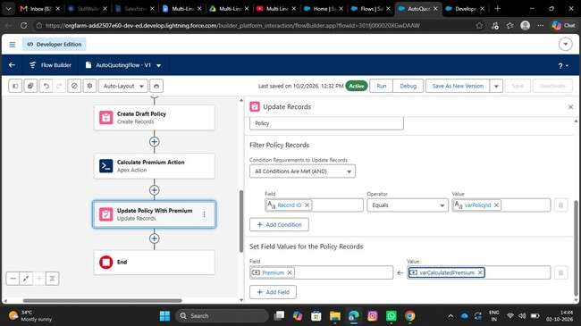
- Activate the flow.
- Save the flow as a new version

Create a Record-Triggered Flow (After Save) on the Claim object
- Go to setup, In the quick find box, Search for flows and click on flows
- Click on New Flow, select Record Triggered Flow and Click on Create
- Select Claim for an object
- Configure trigger when the record is created
- Optimize flow for action and Related Records

• 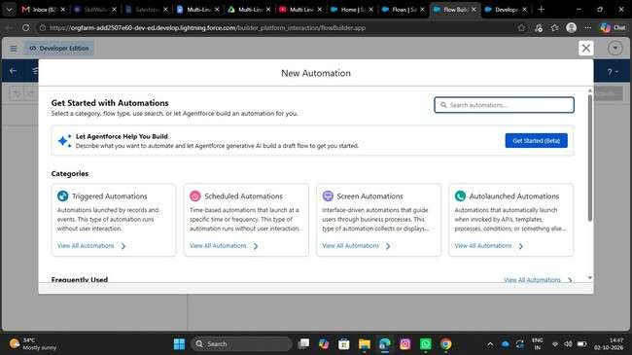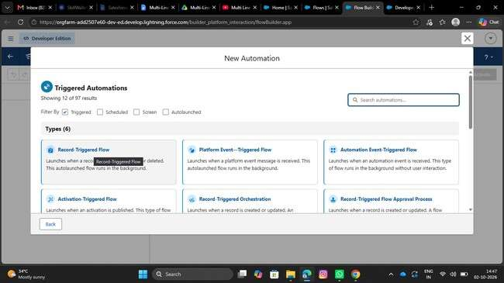
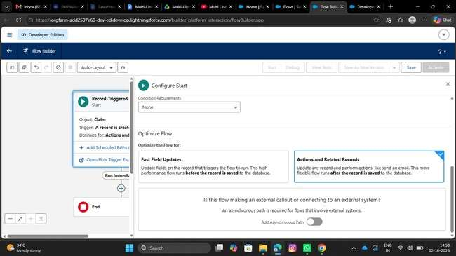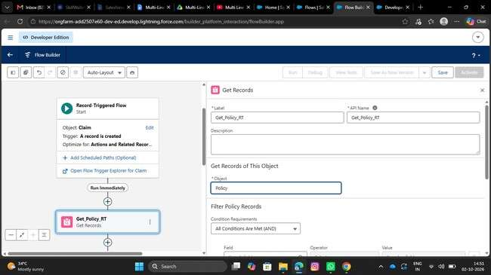
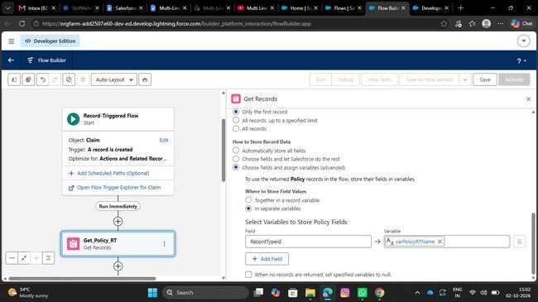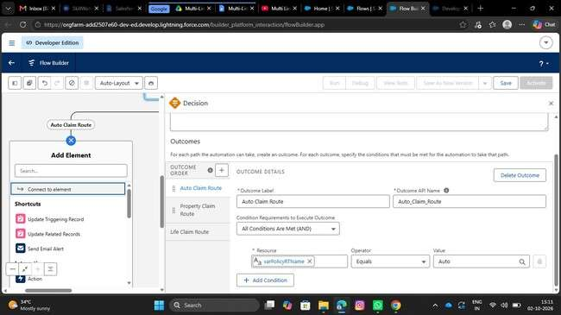
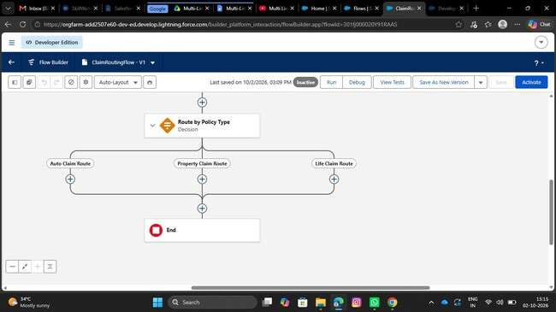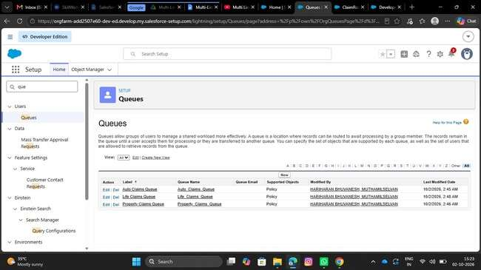
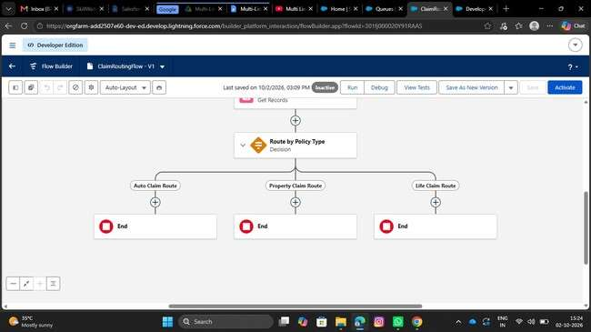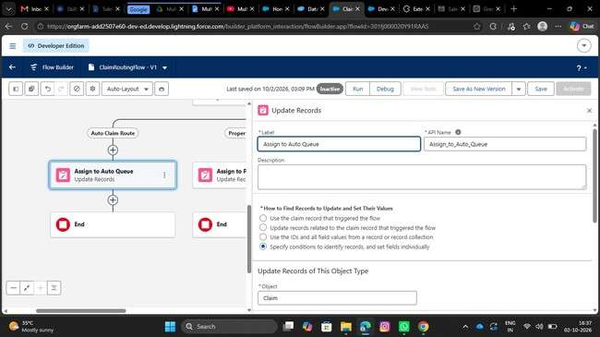
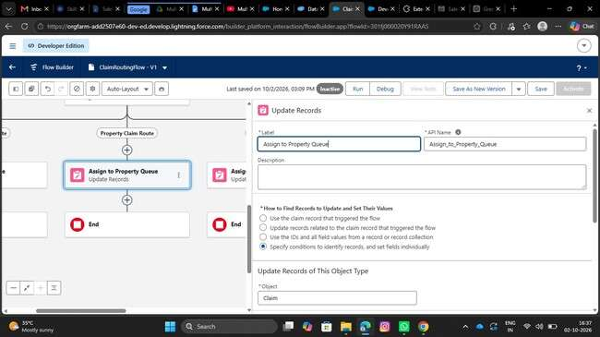
- Under Property Claim Route Decision path, add the update records element
- Label it as Assign to Property Queue
- API name will be auto populated
- Under How to find records to update and set their fields, select specify conditions to identify records
- Select Claim as an object
- Select All conditions are true for Conditional requirements
- The conditions include:
- Record Id equals Triggering Claim → Record ID
- Under Set fields for the Claim Records
- Set the hardcoded Property queue 18 digit Id for Owner ID field
- Under Life Claim Route Decision path, add the update records element
- Label it as Assign to Life Queue
- API name will be auto populated
- Under How to find records to update and set their fields, select specify conditions to identify records
- Select Claim as an object
- Select All conditions are true for Conditional requirements
- The conditions include:
- Record Id equals Triggering Claim → Record ID

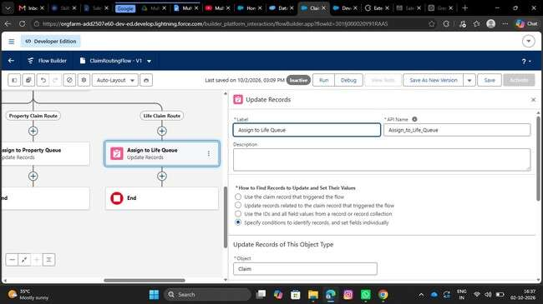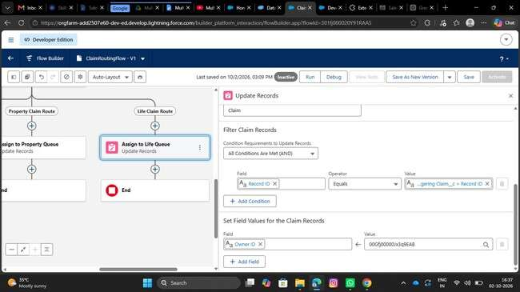
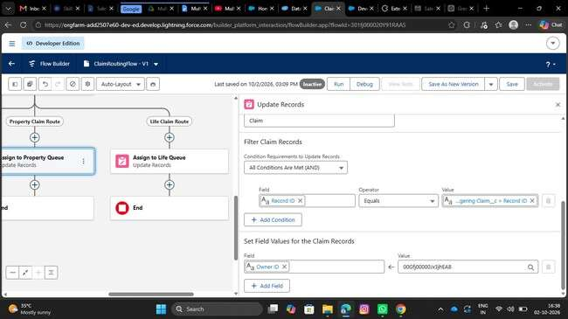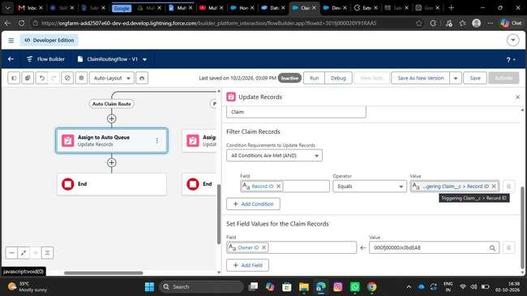

Milestone 3: Claims Adjuster LWC Dashboard Development
1. Create a robust Apex class (ClaimsAdjusterController) with a method using SOQL to query all Claims owned by the logged-in user, joining related Policy and Customer data. The method must return a custom Wrapper Class listing key metrics.
- Click on setup icon, Right click on developer console, Open the link in new tab
- At the top left corner, click on the file, then click on new, and click on Apex class, Give the name as ClaimsAdjusterController and click on create.
- Paste the following code in the apex class: public class
ClaimsAdjusterController {
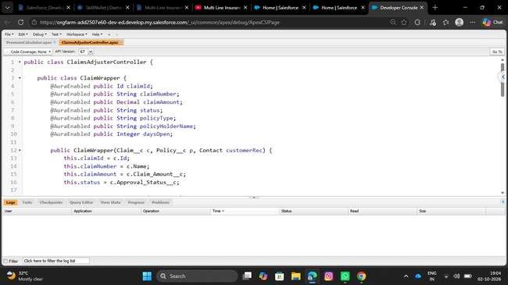
- Save the file using CTRL + S
- This apex class will be handled in the LWC component
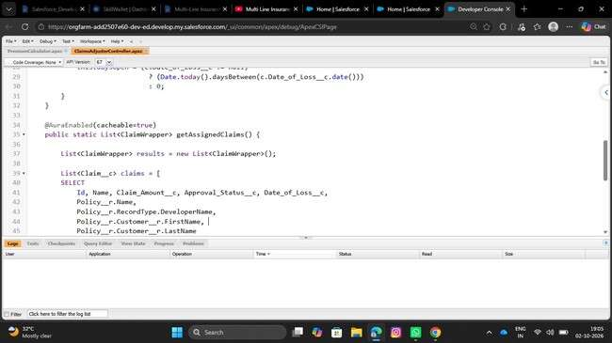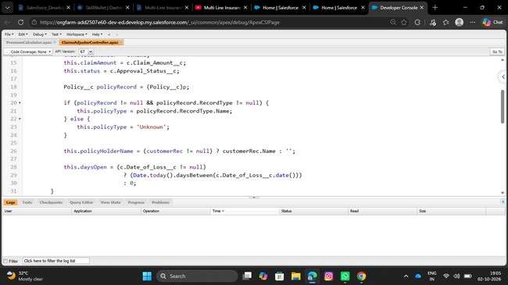
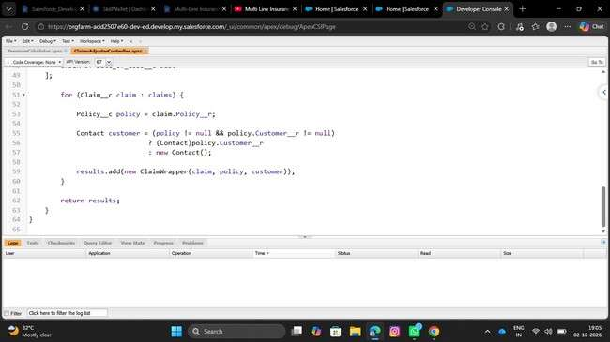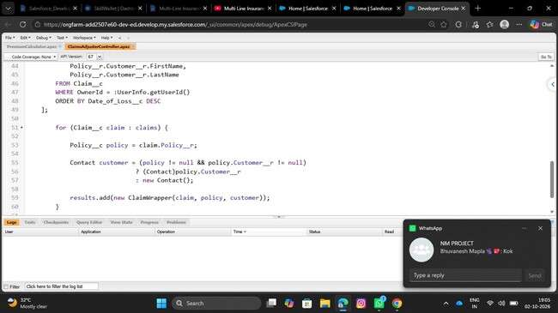
2.Create a component (claimsDashboardLwc) that uses the Apex method via the @wire service and implements client-side data filtering
- Open the new tab in chrome and search for lightning studio extension
- Open the first link and click on add to chrome, and confirm by clicking add Extension button
- Now open the Lightning studio extension from your salesforce org
- On the Top left corner, you will find Create New
- Click on Create New and Click on Lightning Web Component
- Enter the name of the Component as claimsDashboardLwc
- Check the isExposed checkbox
- Under target configurations, Select Lightning app page, Home page and Record page
- Click on Deploy
- Open the HTML file and paste the following code:
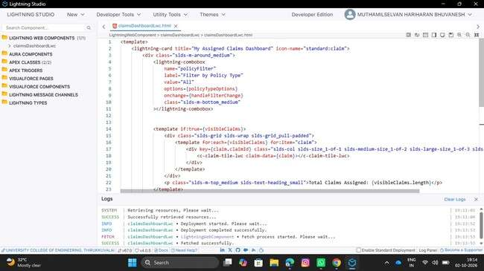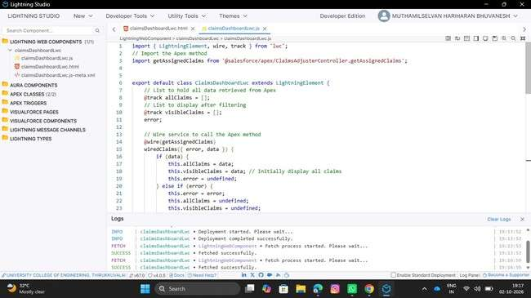

- Open the meta-xml file and paste the following code:

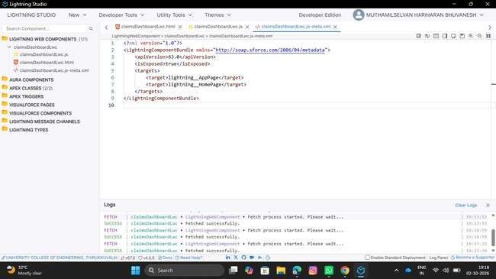
3.Create a reusable component (claimTileLwc) to display essential information for each claim
- Open the Lightning studio extension from your salesforce org • On the Top left corner, you will find Create New
- Click on Create New and Click on Lightning Web Component
- Enter the name of the Component as claimTileLwc
- Check the isExposed checkbox
- Under target configurations, Select Lightning app page, Home page and Record page
- Click on Deploy
- Open the HTML file and paste the following code:

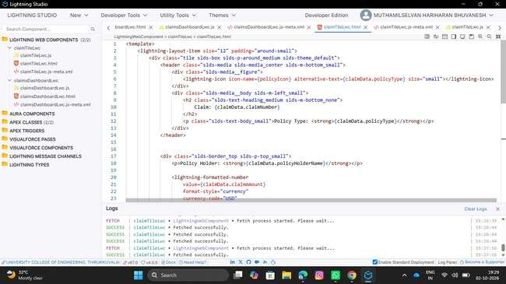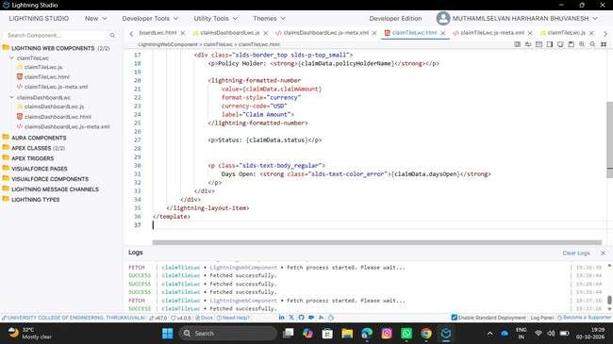
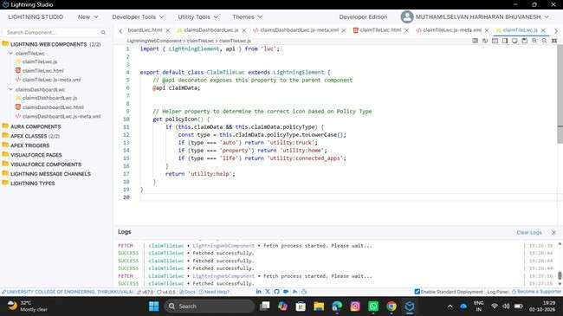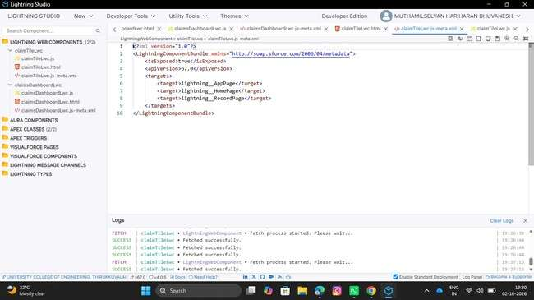

Milestone 4: Advanced Claim Processing, Security & Code
Setup 1. Modify the Claim object to include an Approval Status field.
- Go to set up, Click on object manager, search for claim object and click on claim object.
- In the left side panel, click on fields and relationships.
- Click on new
- Select Datatype as picklist
- Label it as Approval Status
- Select enter values radio button
- Enter New, Submitted for Approval, Approved and Rejected line by line
- Field Name will be auto populated
- Click on Next, Next and Save.
2. Configure the Approval Process to route first to the Senior Adjuster, to the Department Manager, using two sequential steps.
- Go to setup, In the quick find box, Search for Approval process
- Select claim object for Manage approval process for
- Click on create new Approval Process and select use standard setup
- Give the process name as High Value Claim Approval
- Unique Name will be auto populated
- Click on Next

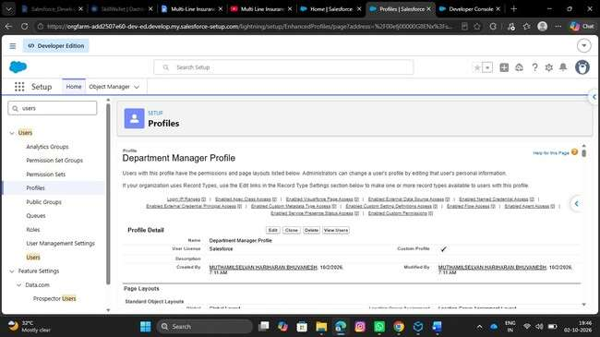
- Under specify entry criteria, Select criteria are met for Use this approval process
- Criteria includes:
- Claim amount greater than 50000
- Click on Next

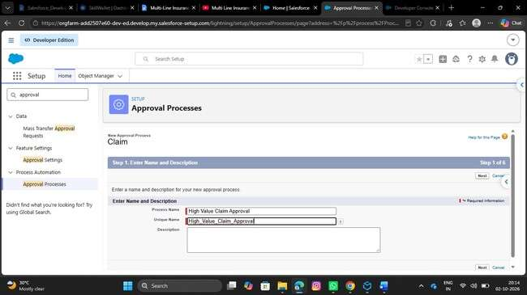
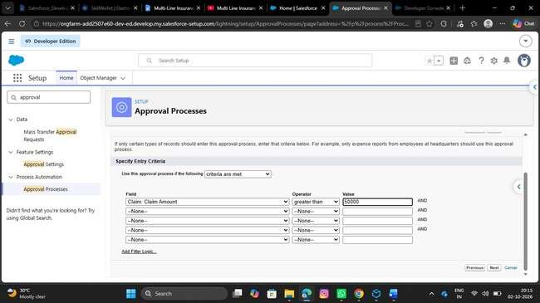
- Under Record Editability properties, Select Administrators ONLY can edit the records during the approval process
- Click on Next

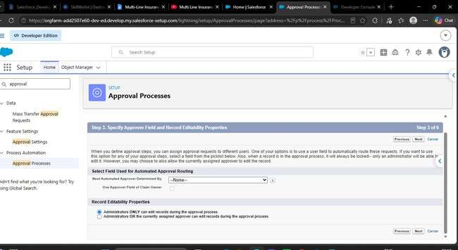
- Click on next again
- Under Approval Page Layout, Select Claim Number, Owner, Claim Amount, Adjuster, Policy fields to the selected fields from available field
- Under security settings, Select Allow Approvers to access the page only from within the salesforce application.
- Click on Next
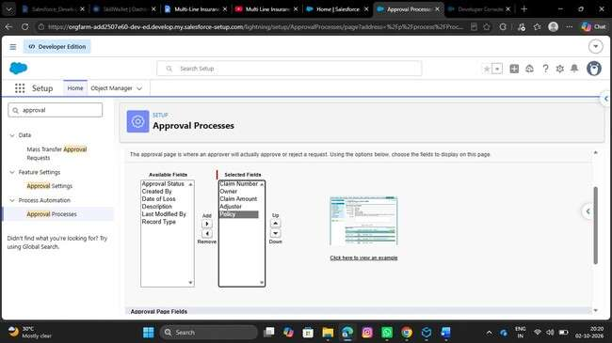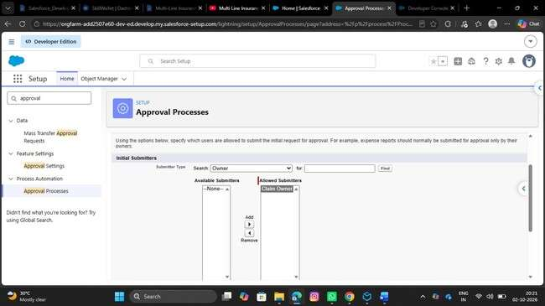
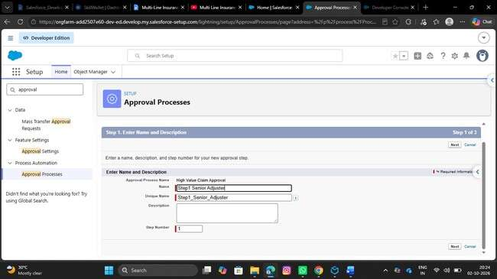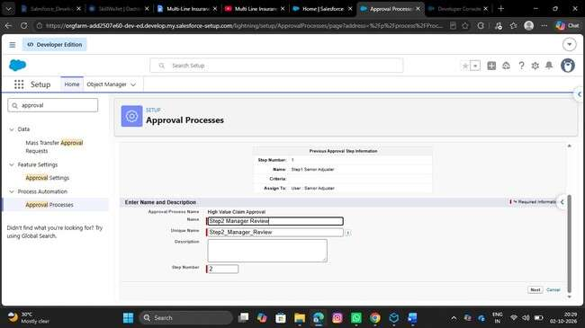
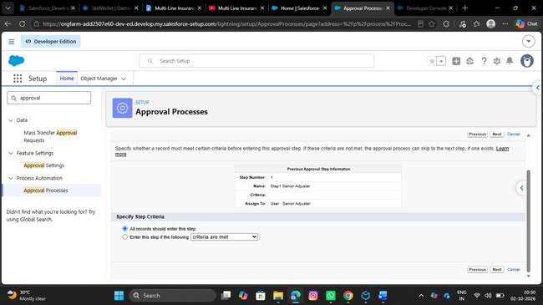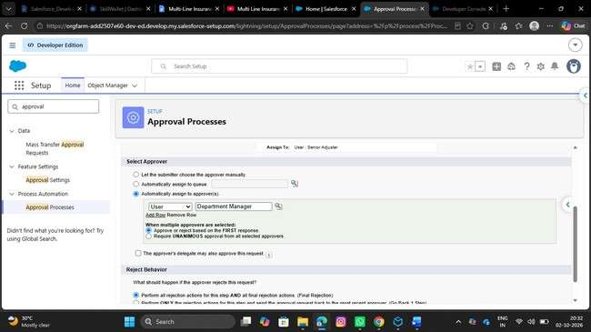
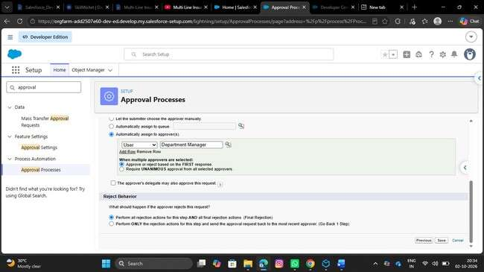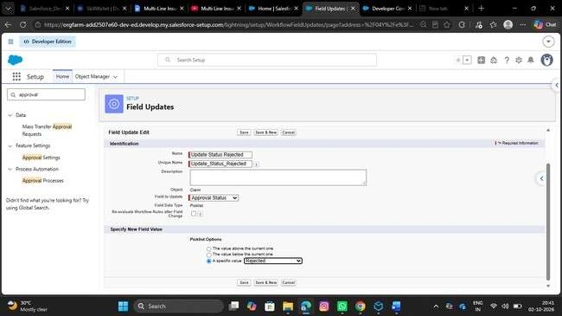
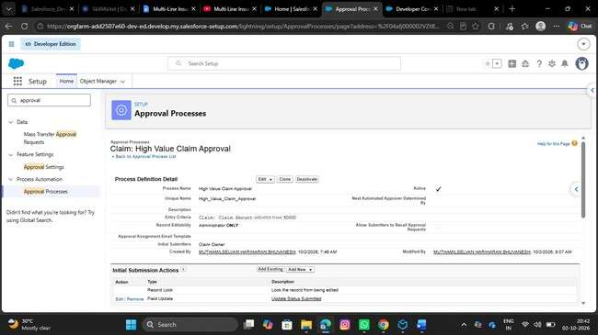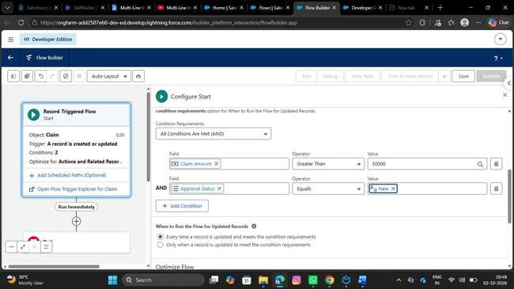

3. 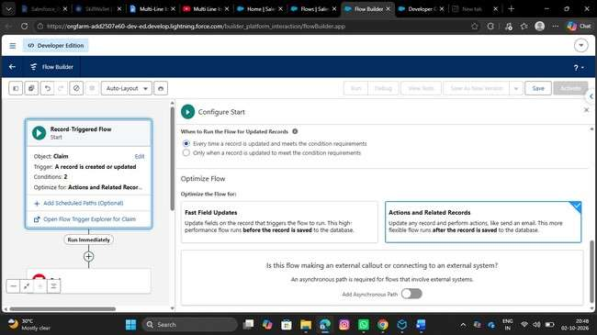

3 .Create a Record-Triggered Flow (After Save)
- Go to setup, In the quick find box, search for flows and click on flows.
- Click on New Flow
- Select Record Triggered Flow
- Select object as Claim
- Configure Trigger When a Record is created or updated
- Select All conditions are true for conditional requirements

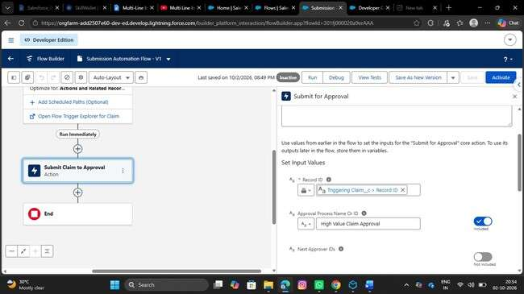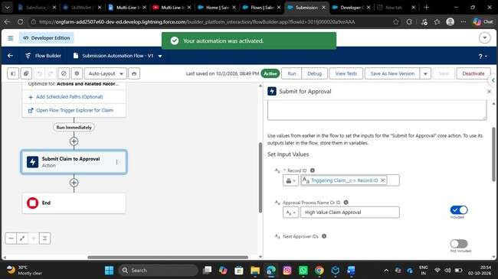

4. 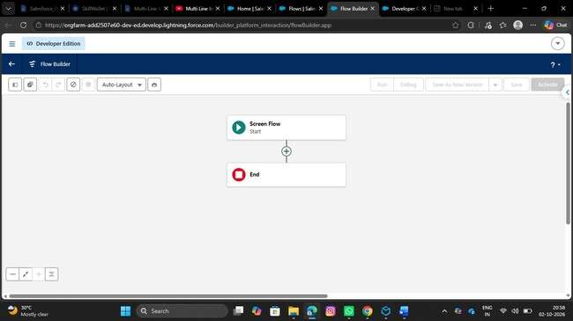
4 .Implement a Screen Flow for the approvers to quickly review details and approve/reject directly from the Claim record.
- Go to setup, Search for flows in the quick find box and click on flows.
- Click on New Flow, Choose Screen Flow
- Create a New Resource by clicking on New Resource button in the toolbox manager
- Resource Type would be Variable
- API Name would be recordId
- Data type would be Text
- Under Availability outside the flow, Check Available for Input
- Click on Done
- Add the Get Records Element below the screen
- Label it as Get Claim Details
- Select object as Claim
- Select All conditions are required for conditional Requirements
- The Condition include:

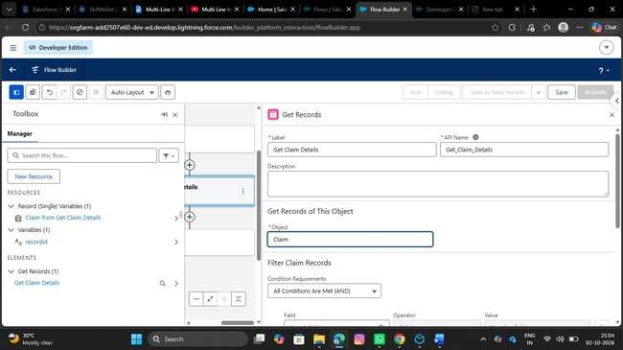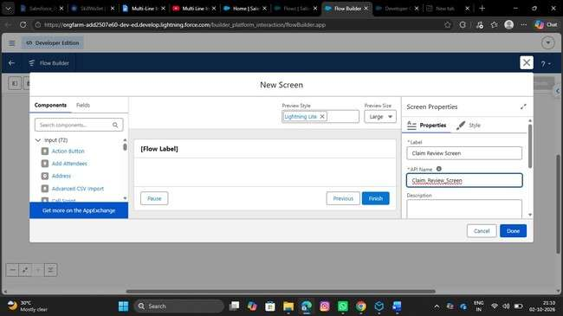
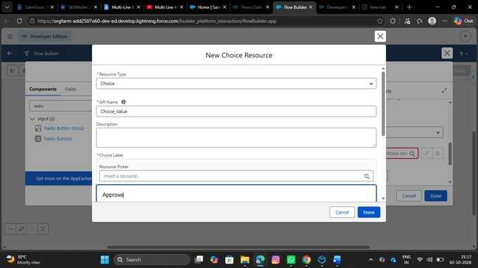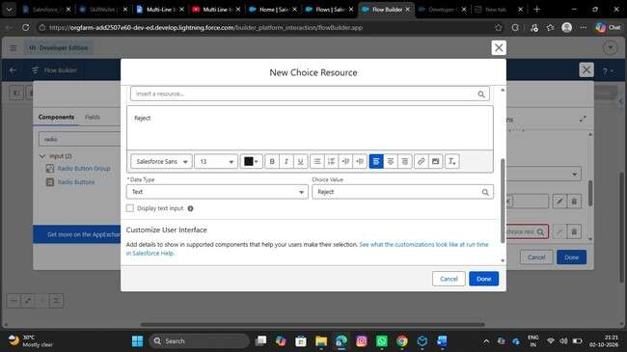
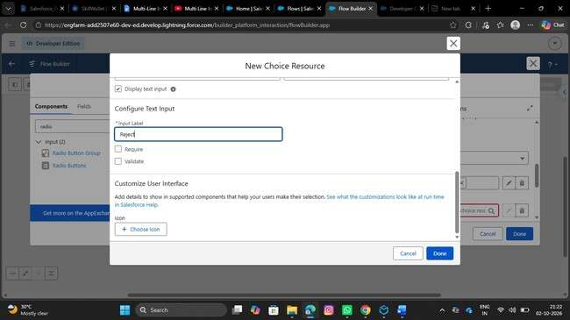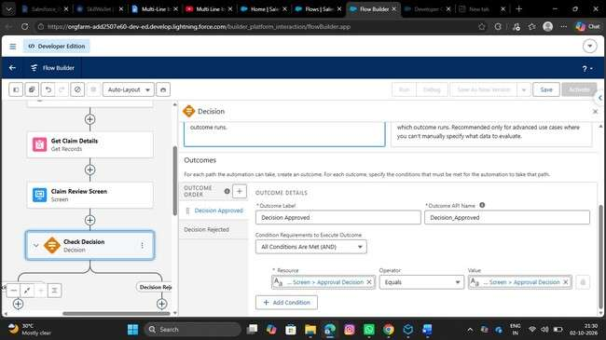
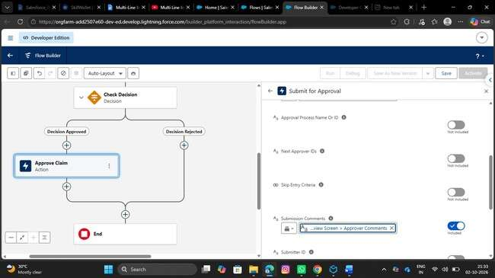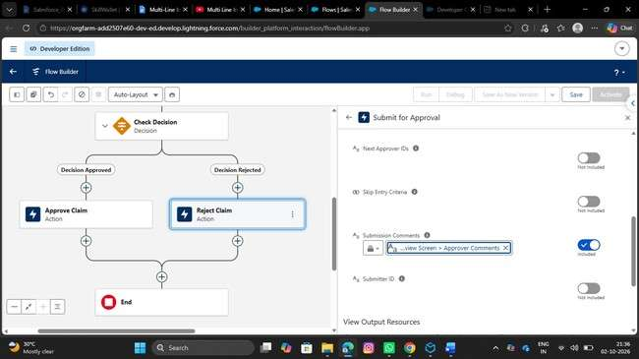
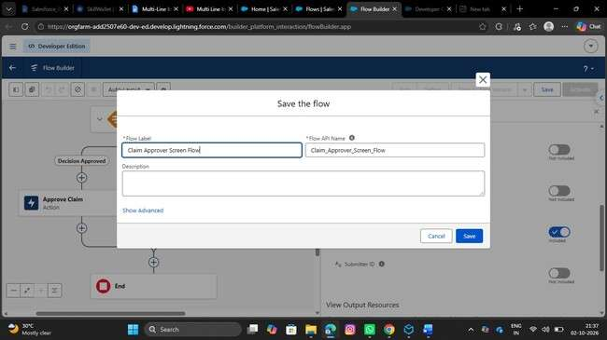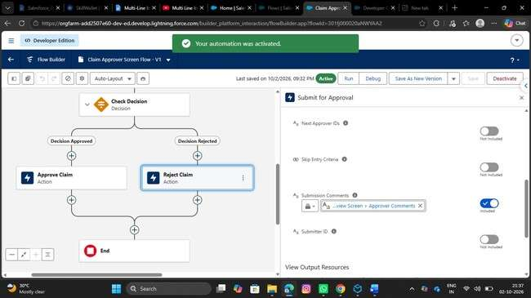

5.Write an apex test
the ClaimsAdjusterController with 95%+ code coverage. Include test methods for complex claim filtering and data retrieval logic

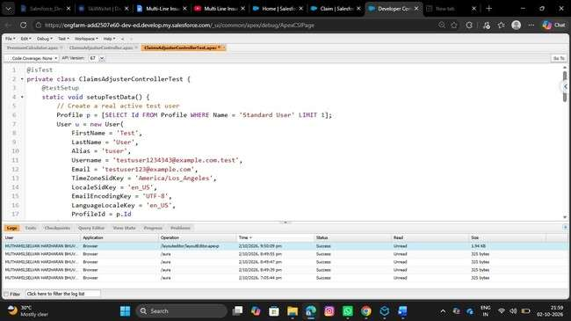
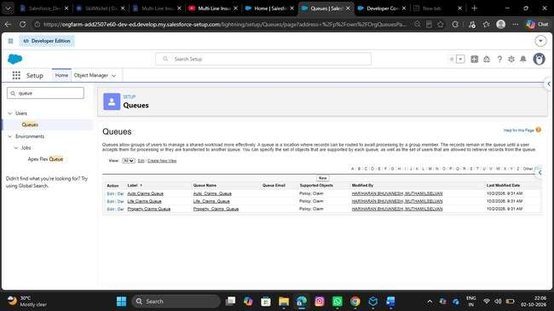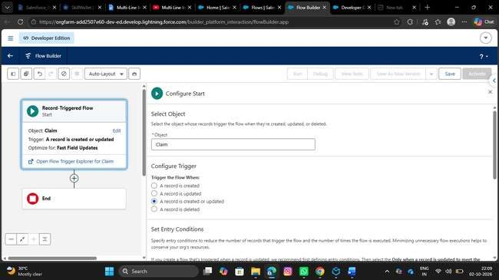
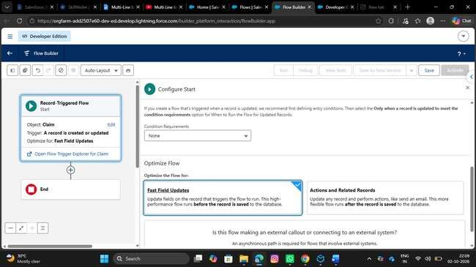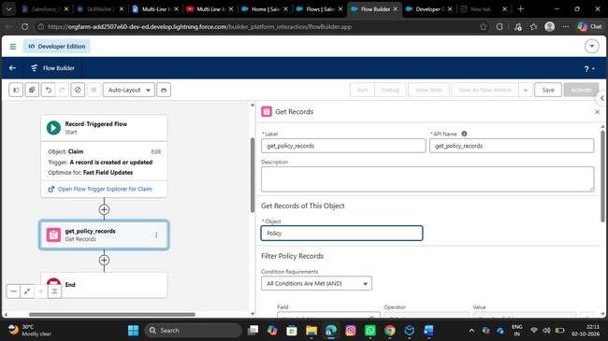
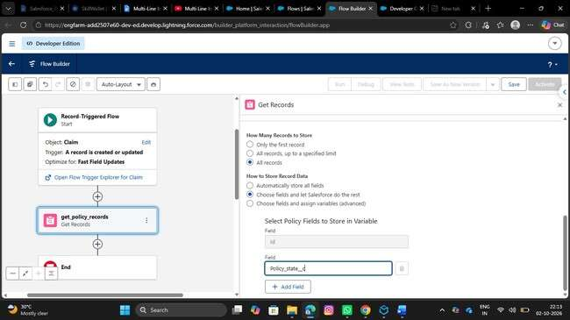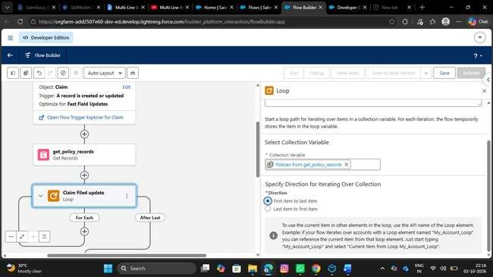
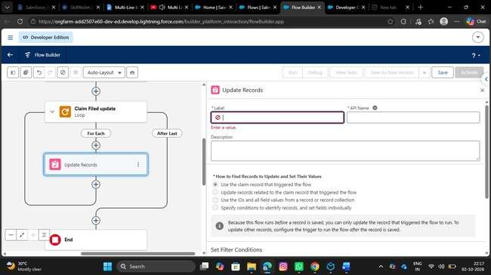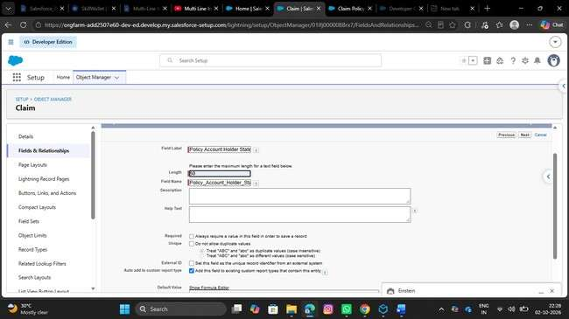
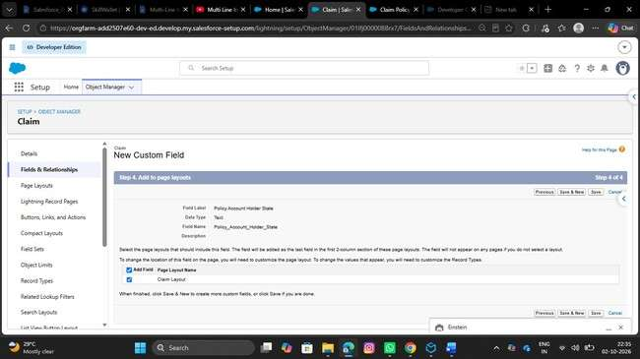

6. Refine the Sharing Rules to ensure Adjusters
- Go to setup, Search for flows in the quick find box and click on flows
- Click on New Flow
- Select Record Triggered Flow
- Select the object as claim
- Configure trigger when a record is created or updated

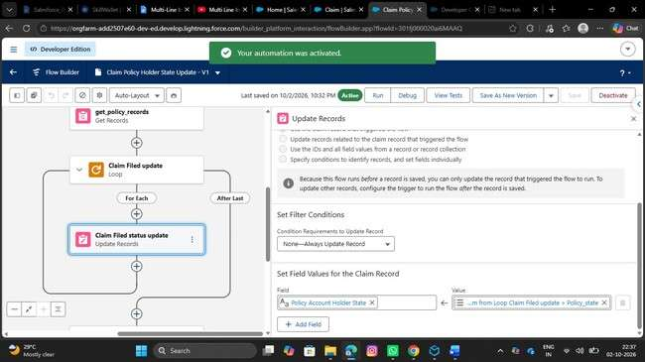
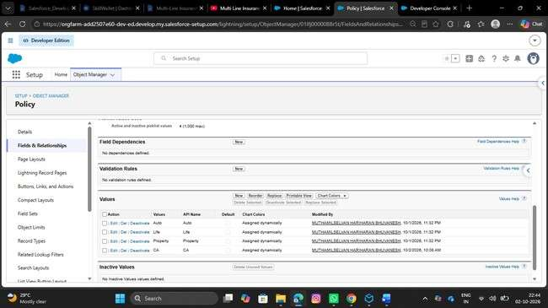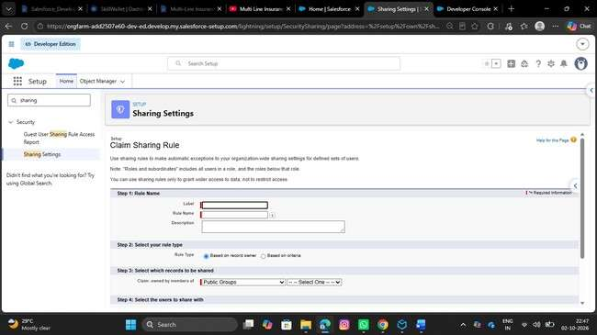
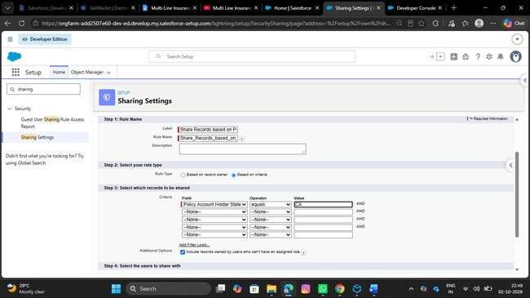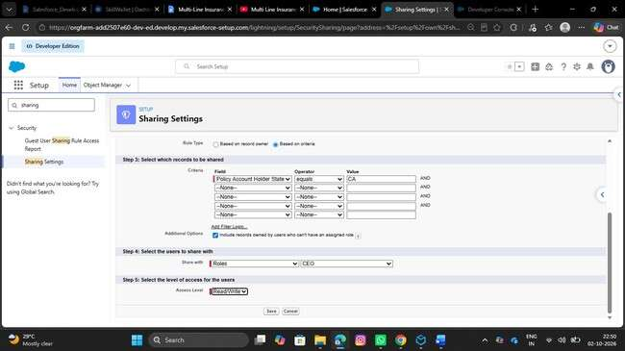

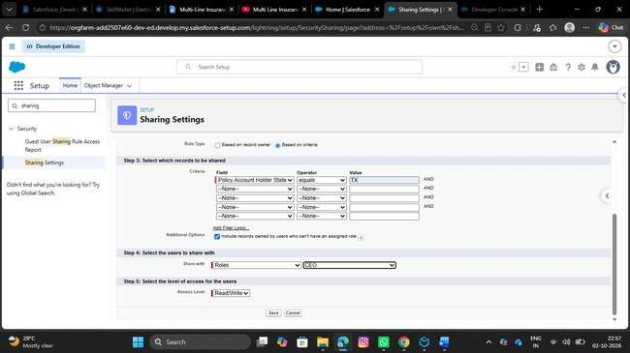

7. Finalize all Permission Sets
- Go to setup, In the quick find box, Search for Permission Sets, Click on Permission Sets
- Click on New
- Give the Label as Insurance Agent Access
- API Name will be Auto Populated

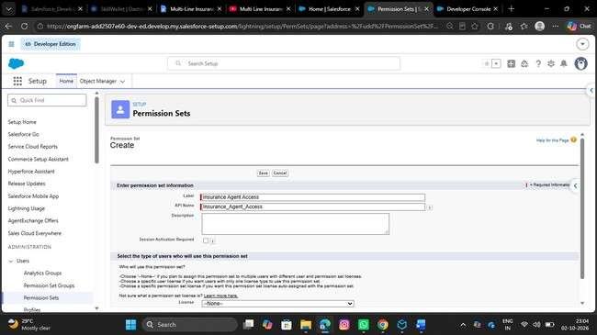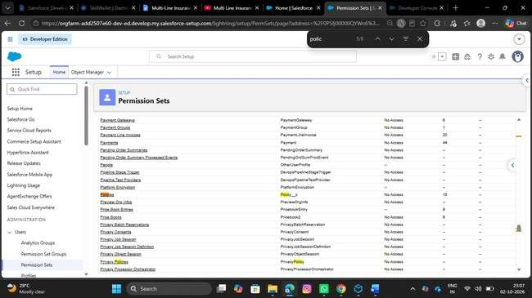
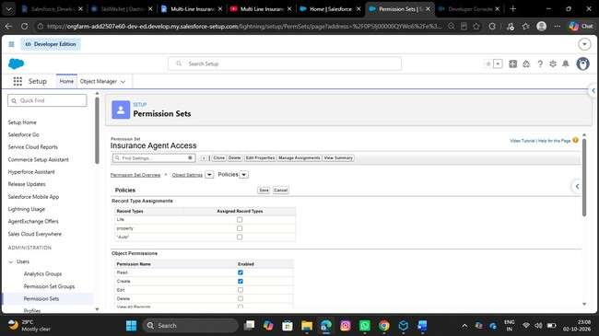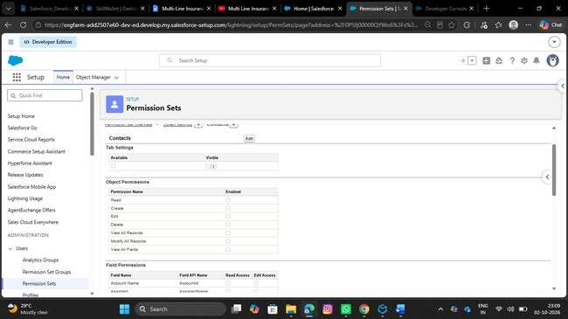
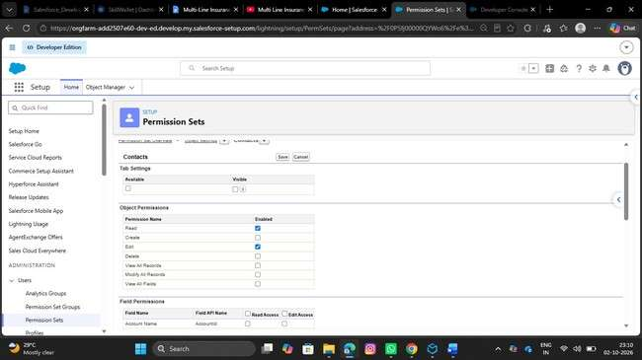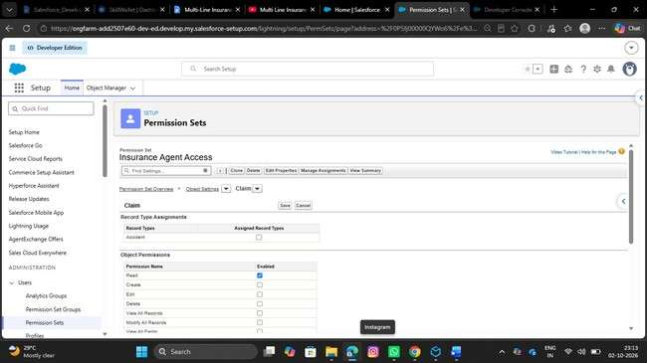
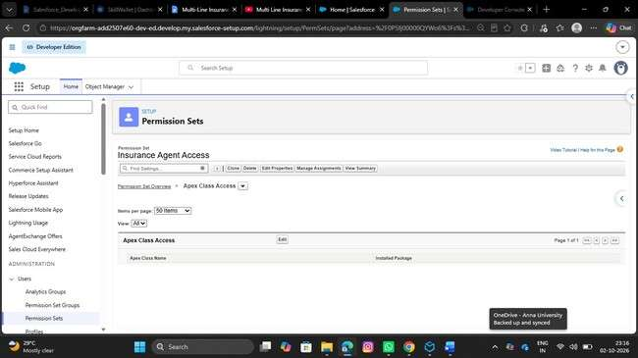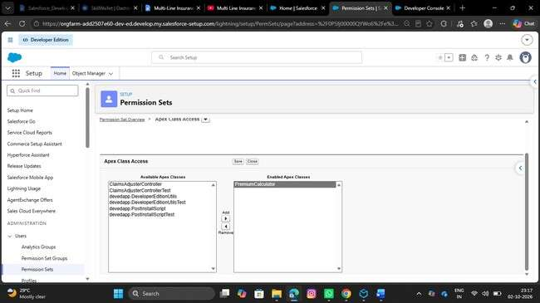
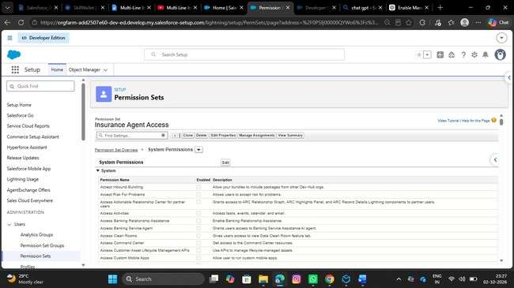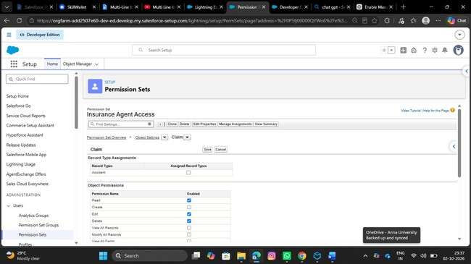
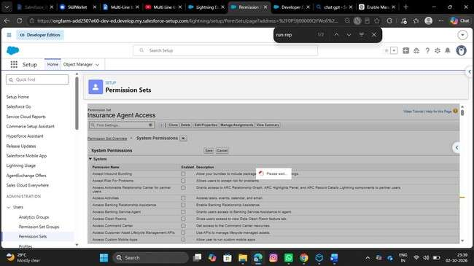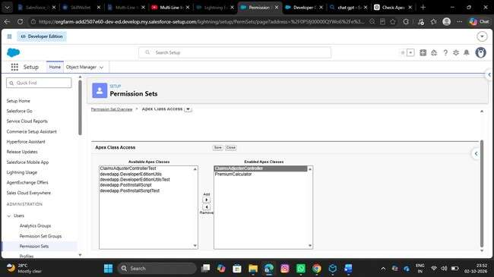
- Give the access to objects
- Give Read Only for Policy object
- Give Read, Edit to Claim object
- Make ClaimsAdjusterController Enabled under Apex Classes

6. FUNCTIONAL & PERFORMANCE TESTING
Testing should cover the complete implementation: data model, quotation flow, VIN validation, premium calculation, claim routing, dashboard, filtering, approval, sharing and permissions.

Test area | Expected result
Policy Record Types | Auto, Property and Life records can be created.
AutoQuotingFlow | Draft Policy is created from entered details.
VIN Validation | Invalid VIN length is rejected for Auto
emium Calculation | Premium is calculated and saved.
Claim Routing | Claims go to the correct queue
LWC D Pr ashboard | Assigned claims are displayed.
Dashboard Filter | All/Auto/Property/Life filtering works.
Approval | High-value claims enter approval stages.
Security | Role and sharing access works as configured
Apex Test | Controller tests execute successfully.

7. ADVANTAGES & DISADVANTAGES

Advantages
- Centralized Vehicle, Property and Life insurance management.
- Guided quotation using Screen Flow.
- Automated premium calculation.
- Automatic claim routing.
- Structured high-value claim approval.
- Focused LWC dashboard.
- Validation improves data consistency.
- Flexible Record Types and Field Sets.
- Role/state-based access control.

Disadvantages
- Multiple Salesforce components require maintenance.
- Different products need different data and rules.
- Automation requires careful testing.
- Apex and LWC need technical skills.
- Configuration changes may affect dependent automation.

8. CONCLUSION
The Multi-Line Insurance Policy and Claims Management System brings policy and claim activities into one Salesforce solution. The milestone structure provides a clear implementation sequence: build the data model, add policy and claim automation, develop the adjuster dashboard, and complete approval, testing and security.

9. FUTURE SCOPE
- Extend quotation flows to Property and Life.
- Integrate external vehicle or property databases.
- Add advanced premium-rating rules.
- Add more dashboard metrics and reports.
- Add claim and approval notifications.
- Support additional insurance products.
- Improve automated testing and deployment.

10. APPENDIX
A. Main Salesforce Components

Component | Purpose
Policy__c | Stores policy information.
Claim__c | Stores claim information.
Record Types | Separate insurance products and claim types.
Field Sets | Group product-specific fields.
AutoQuotingFlow | Guided Auto quotation.
PremiumCalculator | Calculates premium
ClaimsAdjusterController | Retrieves assigned claims.
claimsDashboardLwc | Displays and filters claims.
claimTileLwc | Displays individual claim details.
Approval Process | Handles high-value approvals

B. Team Implementation Checklist
Milestone | Completion Check
Milestone 1 | Objects, fields, Record Types, Field Sets, AutoQuotingFlow and VIN validation.
Milestone 2 | Premium calculation and claim routing.
Milestone 3 | Apex controller and LWC dashboard components.
Milestone 4 | Approval, approver flow, testing, sharing and Permission Sets.
Final | Functional testing and evidence/screenshots collected
C. Team Member
Name | Role
Hariharan R | Team lead
Muthamilselvan T | Member
Bhuvanesh C T | Member

